Zoom Tips

- If the Chat Pop Ups are driving you crazy during a meeting, you can click “Pop Out” on the side and it will move your chat to a different window. This way, you will not receive an alert every time a new comment shows up.
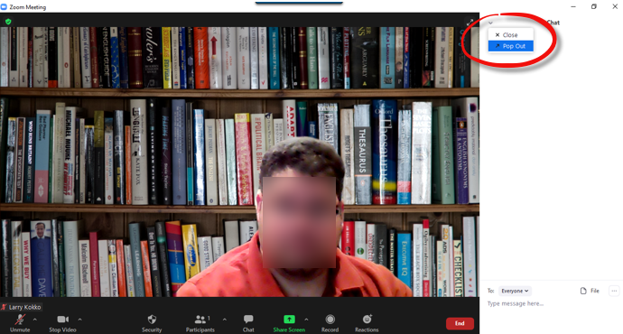

- From your Start/Stop Video icon, you can touch up your appearance by clicking the option arrow, choose Video Filter and select Studio Effects at the bottom right side of the screen. Give yourself full eyebrows or yellow lipstick.
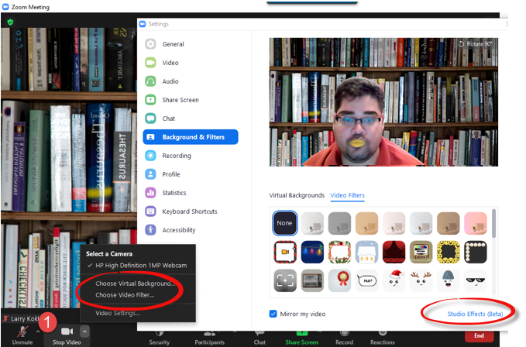

- You can follow this link to upload Toastmaster Timers to your Virtual Background. https://www.youtube.com/watch?v=Zh82_qkN1nU
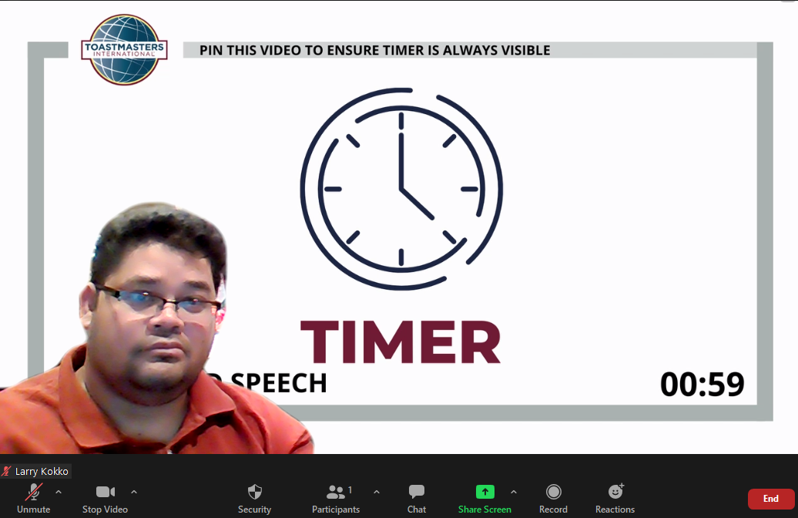
- If you would like to share a video during a meeting but cannot seem to get the sound to go through – you may be missing this one crucial step. Before clicking the Share button, look to the bottom left of the screen for the Share Sound Option:
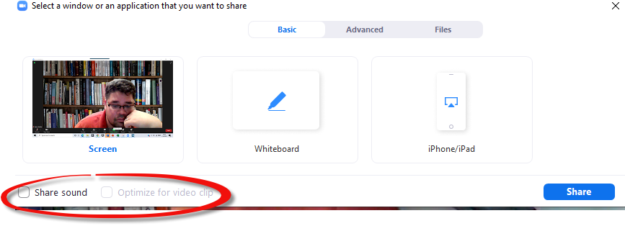
- You also have Advanced Options available to you when select Share Screen:
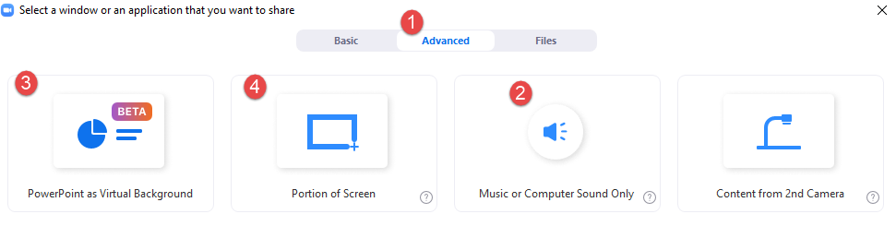
- Click Advanced at the top
- Click this if you want to share Sound Only without sharing your screen content. This is helpful if you want to use the Applause Sound Byte at https://www.classtools.net/soundboard/
- Click this is you only want to share a portion of your screen. This is helpful if you are presenting a PPT and only have one monitor. You can use the PPT Presenter view, only share a portion of your screen and still have your notes available to read without letting the audience see.
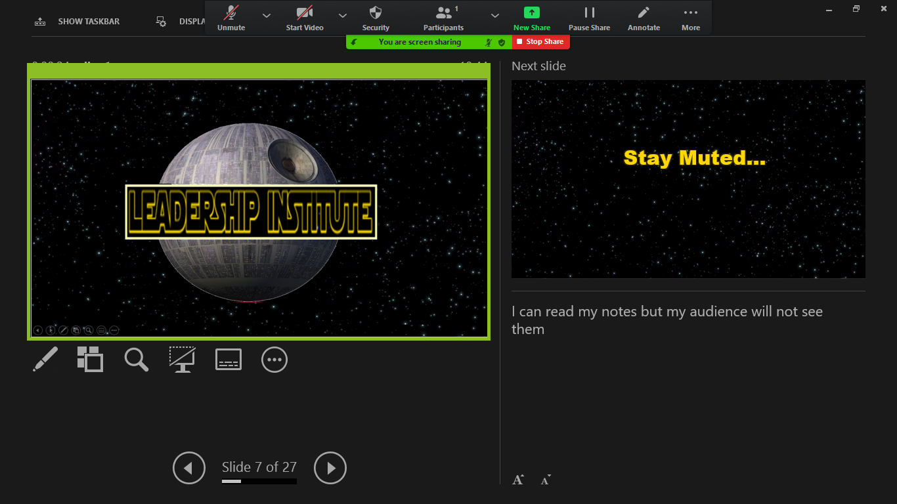
- Click this if you would like to have your Virtual Background BE your PPT presentation

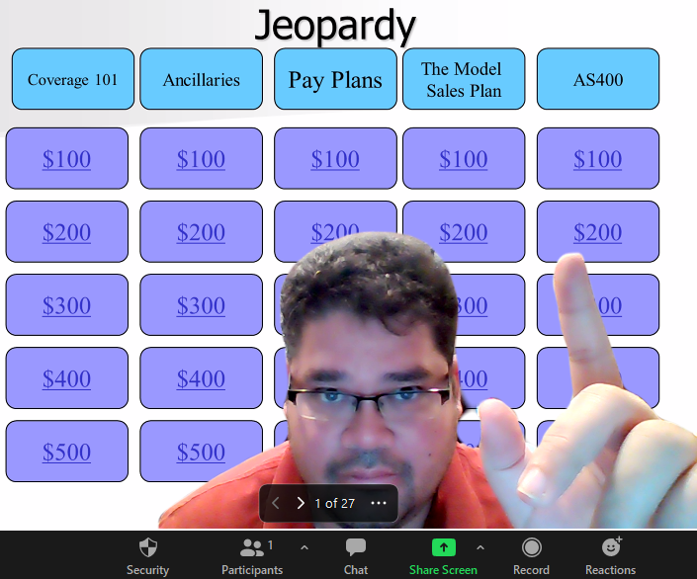
Additional Resources
- Zoom Tips/Instructions: https://www.cnet.com/google-amp/news/how-to-use-zoom-15-video-chat-tips-and-tricks-to-try-today/
- Hot keys and keyboard shortcuts – Zoom Help Center
- Link to Find a Club: https://www.toastmasters.org/resources/online-only-clubs
- Zoom Background Options: https://unsplash.com/s/photos/zoom-background
- Link to DIY Green Screen: Green Screen for $6 - https://youtu.be/4wySe_NqfEU

